**Assignment 06**

**KD1-Indrajeet-86641**

Q1. Write two different queries that would produce all orders taken on October 3rd or 4th, 1990.

🡺 **1)** **select * from orders where odate = ‘1990-10-03’ or odate = ‘1990-10-04’;**

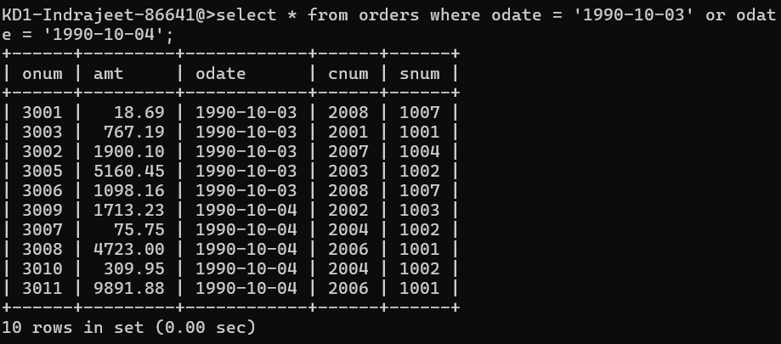

**2)** **select * from orders where odate > ‘1990-10-02’ and odate < ‘1990-10-05’;**

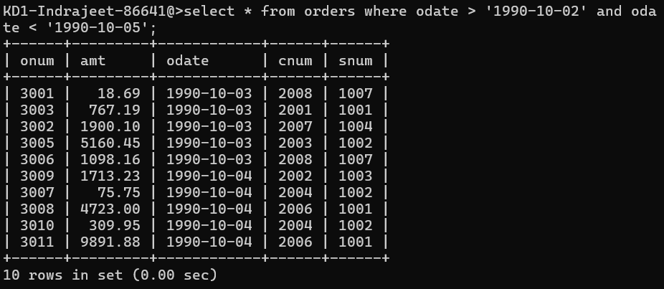

Q2. Write a query that selects all of the customers serviced by Peel or Motika. (Hint: the snum field relates the two tables to one another).

Q3. Write a query that will produce all the customers whose names begin with a letter from ‘A’ to ‘G’..

🡺 **Answer1: select * from customers where ascii(cname) > 64 and ascii(cname) < 73;**

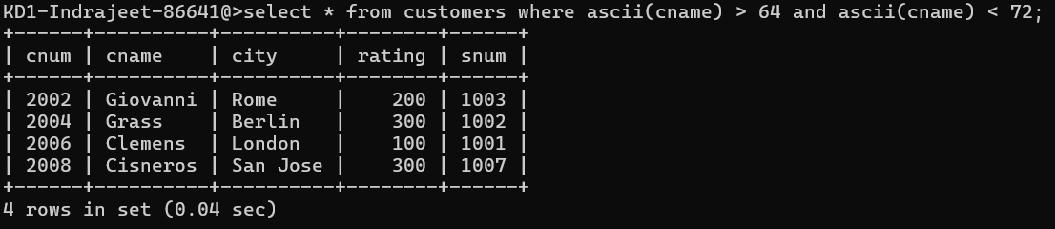

**Answer 2: Select * from customers where cname between ‘a’ and ‘h’;**

Q4. Write a query that selects all customers whose names begin with the letter ‘C’.

🡺 **select * from customers where cname like ‘C%’;**

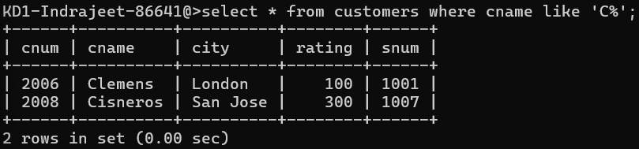

Q5. Write a query that selects all orders except those with zeroes or NULLs in the amt field.

🡺 **select * from orders where amt != null and amt != 0;**

